**Exercise 1: Setting Up Junit**

STEP 1: Create a new Java project in your IDE (e.g., IntelliJ IDEA, Eclipse).

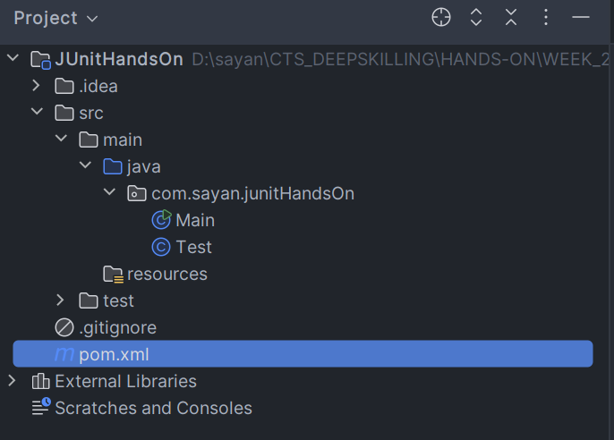

STEP 2: Add JUnit dependency to your project. If you are using Maven, add the following to your pom.xml:

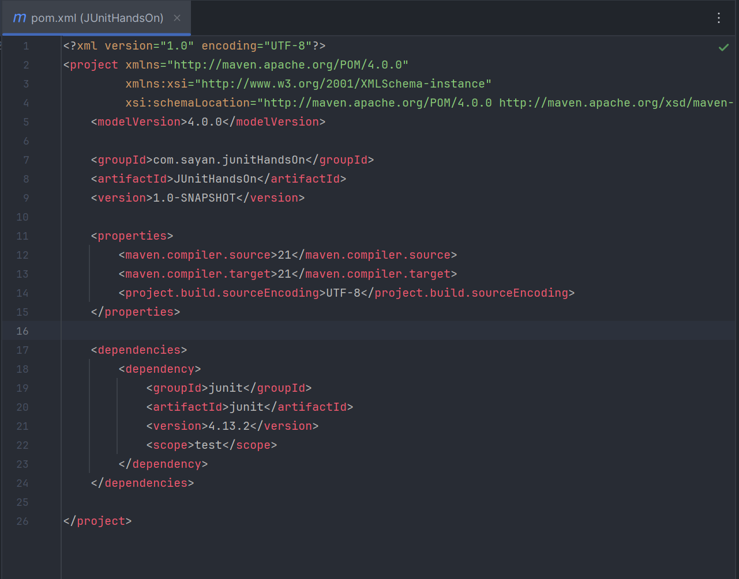

STEP 3: Create a new test class in your project.

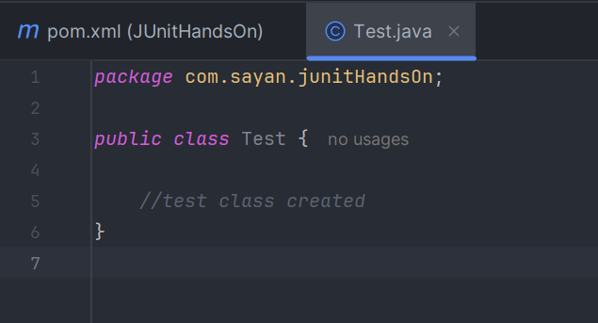

**Exercise 3: Assertions in Junit**

1. Write tests using various JUnit assertions.

*package* com.sayan.junitHandsOn;  
  
*import* org.junit.*Test*;  
  
*import static* org.junit.Assert.*;  
  
*public class* AssertionsTest {  
 *@Test  
 public void* testAssertions() {  
 *// Assert equals* assertEquals(5, 2 + 3);  
  
 *// Assert true* assertTrue(5 > 3);  
  
 *// Assert false* assertFalse(5 < 3);  
  
 *// Assert null* assertNull(*null*);  
  
 *// Assert not null* assertNotNull(*new* Object());  
 }  
}

OUTPUT:

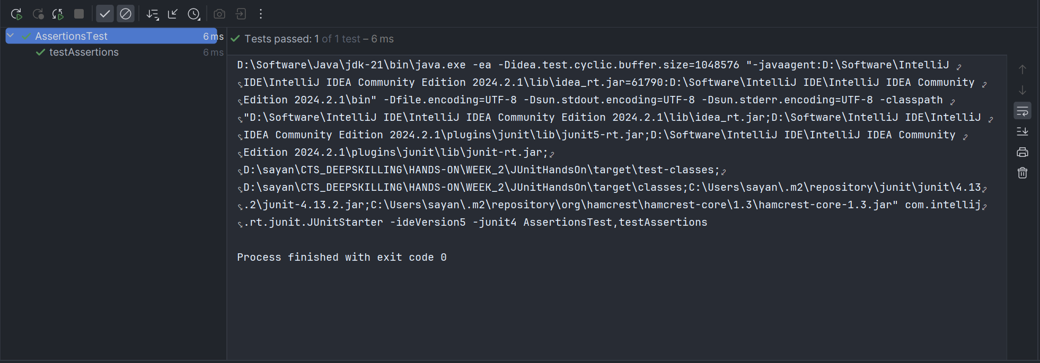

**Exercise 4: Arrange-Act-Assert (AAA) Pattern, Test Fixtures, Setup and Teardown Methods in Junit**

1) Write tests using the AAA pattern.

1. Creating the **Class Under Test.**

*public class* Calculator {  
  
 *public int* add(*int* a, *int* b){  
 *return* a+b;  
 }  
}

1. Creating a test class named **CalculatorTest** under *test* folder**.**

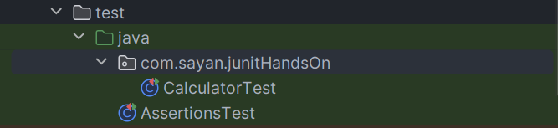

1. Using AAA pattern creating object to test.

*package* com.sayan.junitHandsOn;  
*import* org.junit.*Test*;  
*import static* org.junit.Assert.assertEquals;  
*public class* CalculatorTest{  
  
 *@Test  
 public void* addTest(){  
 *//Arrange: creating instance of class* Calculator cl = *new* Calculator();  
  
 *//Act: Initialize the class to test  
 int* actualResult = cl.add(1,2);  
  
 *//Assert: verifying that the method produces expected output* assertEquals(3,actualResult);  
 }  
}

**OUTPUT:**

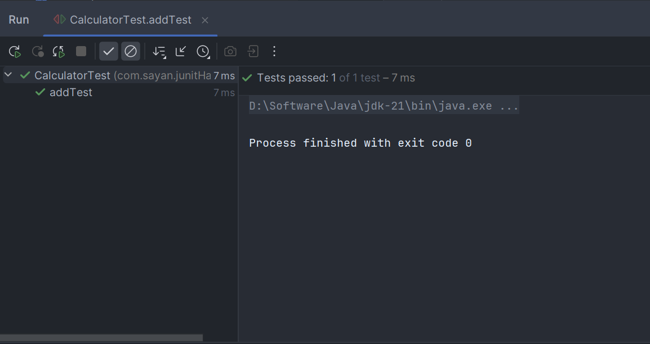

2. Use @Before and @After annotations for setup and teardown methods.

CODE:

*package* com.sayan.junitHandsOn;  
*import* org.junit.*After*;  
*import* org.junit.*Before*;  
*import* org.junit.*Test*;  
  
*import static* org.junit.Assert.*;  
  
*public class* SetUpAndTearDown {  
  
 *@Before  
 public void* setupMethod(){  
 System.out.println("Run before each test");  
 }  
  
 *@Test  
 public void* assertEqualsTest(){  
 assertEquals(1,5-4);  
 System.out.println("----Test 1----");  
 }

*@Test  
 public void* assertTrueTest(){  
 assertTrue(5 == 5);  
 System.out.println("----Test 2----");  
 }  
   
 *@After  
 public void* TearDownMethod(){  
 System.out.println("Run after each test");  
 }  
}

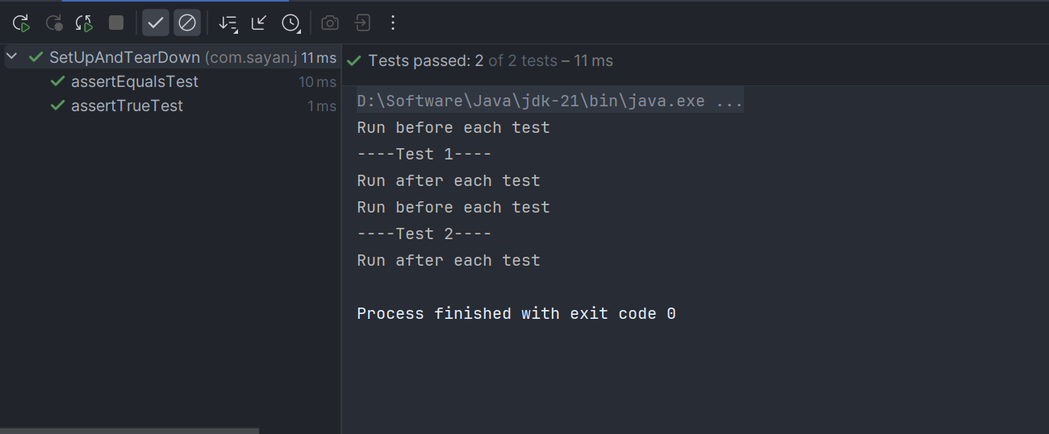**OUTPUT:**